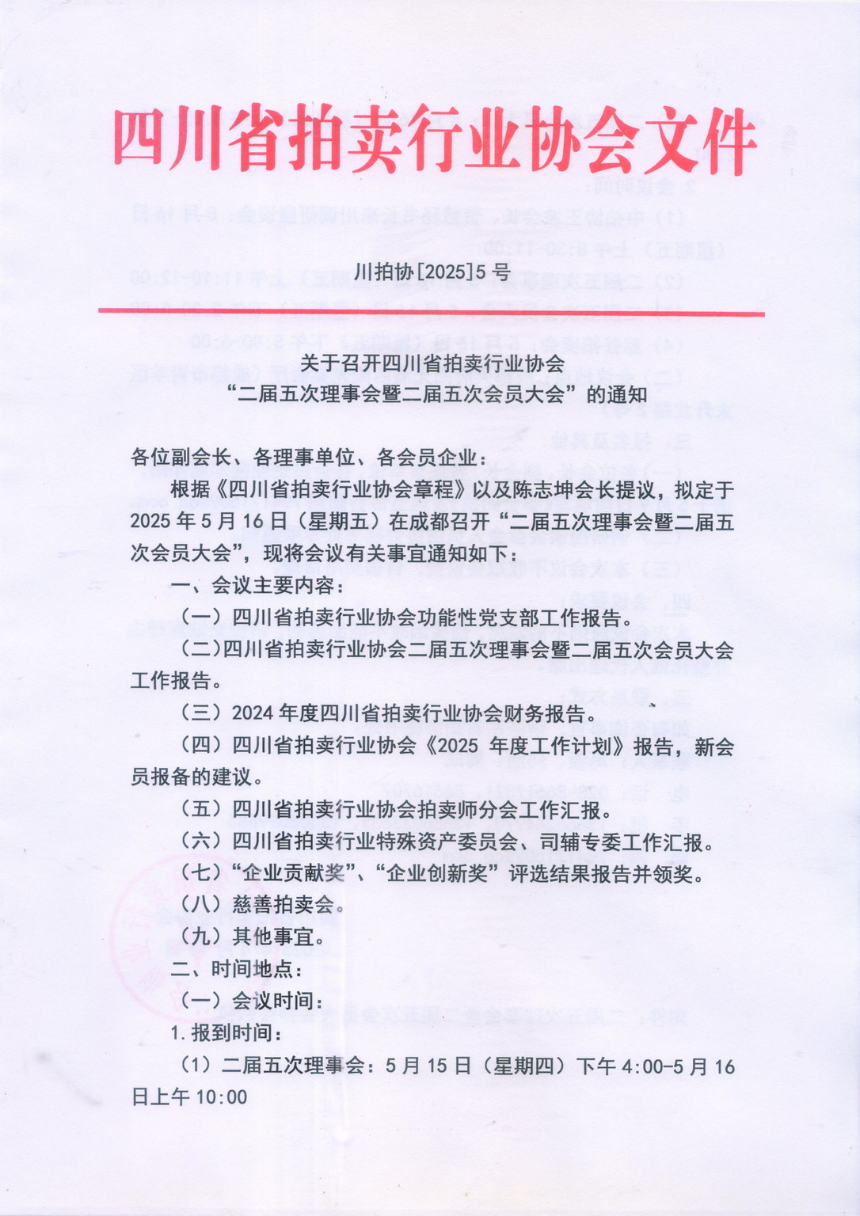

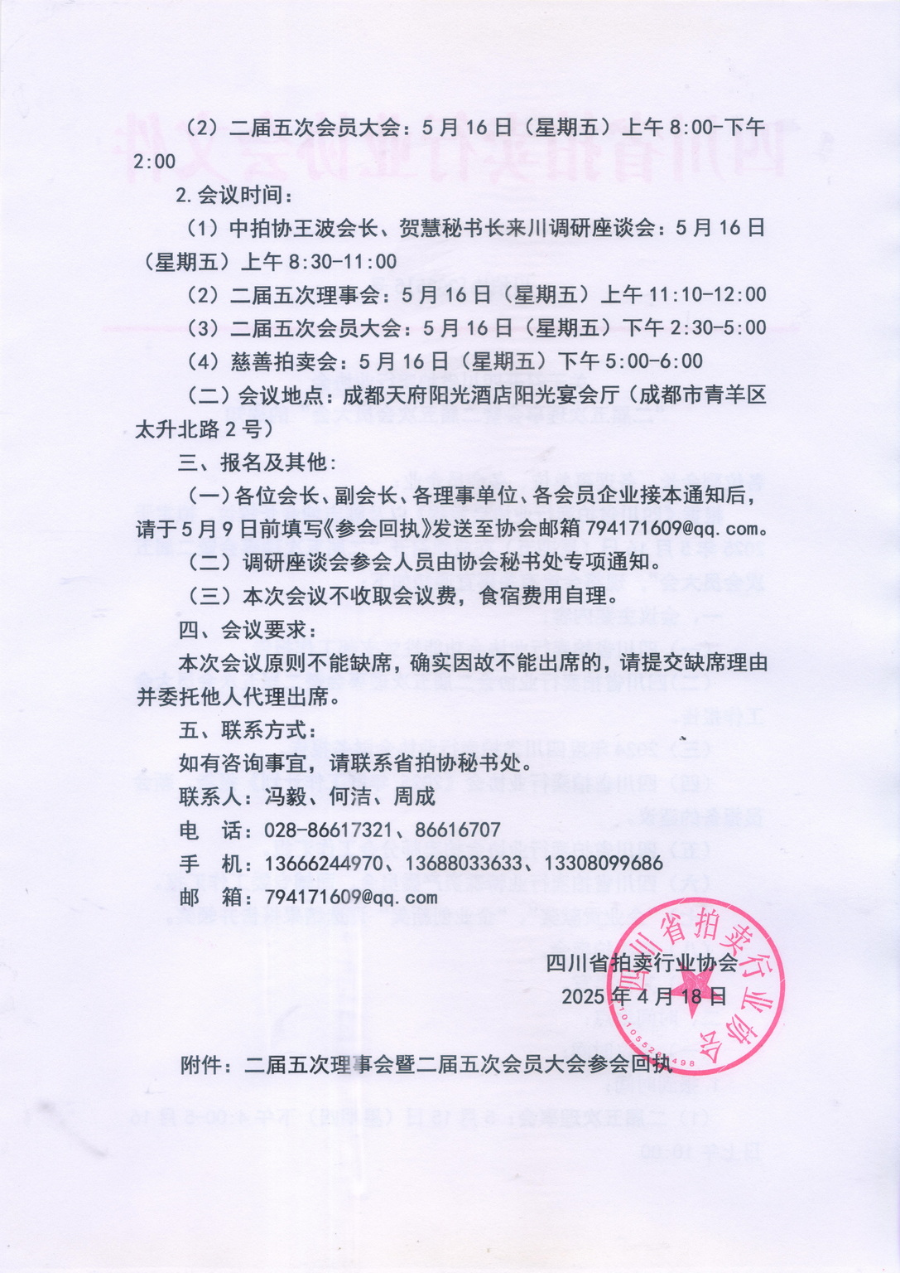

**附件：**

|  |  |  |  |  |  |  |
| --- | --- | --- | --- | --- | --- | --- |
| **二届五次理事会暨二届五次会员大会参会回执** | | | | | | |
| **姓名** | **性别** | **职务** | **单 位** | **手 机** | **是否住宿** | |
| **单间** | **包间** |
|  |  |  |  |  |  |  |
|  |  |  |  |  |  |  |
|  |  |  |  |  |  |  |
| **备注:** | | | | | | |
| **注:请于2025年5月9日前将回执填好后发至省拍协邮箱794171609@qq.com。** | | | | | | |

**会议位置：成都天府阳光酒店（成都市青羊区太升北路2号）**

